Detection of ASD Traits in Children through Behavioral
Analysis in Computerized Game Environment

Himanshu Chauhan
School of Computing Science Engineering and Artificial Intelligence
VIT Bhopal University
Kothri-Kalan, Sehore, India
himanshuchauhan2022@vitbhopal.ac.in

Sahil Ajani
School of Compting Science and Engineering
VIT Bhopal University
Kothri-Kalan, Sehore, India
ajanisahil2022@vitbhopal.ac.in
T. Venkateswara Rao
School of Compting Science and Engineering
VIT Bhopal University
Kothri-Kalan, Sehore, India
venkateswararao@vitbhopal.ac.in

Jayesh
School of Compting Science and Engineering
VIT Bhopal University
Kothri-Kalan, Sehore, India
jayesh2022@vitbhopal.ac.in

Prakhar Pandey
School of Compting Science and Engineering
VIT Bhopal University
Kothri-Kalan, Sehore, India
prakharpandey2022@vitbhopal.ac.in

Abstract— Early detection of Autism Spectrum Disorder (ASD) is crucial for effective intervention, yet current diagnostic methods face accessibility challenges. This study introduces a gamified software tool using computer vision and machine learning to assess ASD-related behaviors through interactive tasks in gesture recognition, color identification, and emotion expression. Developed with a VITE+React+TS frontend and Python backend. The tool offers a scalable, engaging, and cost-effective screening solution, particularly beneficial for low-resource settings. Future work will expand validation and integrate the tool into clinical workflows to improve early ASD detection globally.
Keywords— Autism Spectrum Disorder, early detection, gamified assessment, computer vision, machine learning

Introduction
Autism Spectrum Disorder (ASD) is a complex neurodevelopmental condition characterized by challenges in social interaction, communication, and restricted or repetitive patterns of behavior (American Psychiatric Association, 2013). Early detection and intervention are crucial factors in improving outcomes for children with ASD, yet significant delays in diagnosis remain common worldwide (Zwaigenbaum et al., 2015). The average age of diagnosis in many countries is between 4-5 years, despite evidence suggesting that reliable diagnosis is possible as early as 18-24 months (Daniels & Mandell, 2014; Fernell et al., 2013). This diagnostic delay represents a critical gap in clinical practice, as research consistently demonstrates that interventions initiated before age three yield substantially better outcomes in communication, social interaction, and cognitive development (Dawson et al., 2010; Estes et al., 2015).
The traditional diagnostic process for ASD typically involves multiple clinical assessments conducted by specialists using standardized tools such as the Autism Diagnostic Observation Schedule, Second Edition (ADOS-2) and the Autism Diagnostic Interview-Revised (ADI-R). While these tools demonstrate strong clinical validity, they present several limitations including high cost, extensive training requirements for administrators, limited availability—particularly in low-resource settings and rural areas—and significant wait times due to specialist shortages (Lord et al., 2018; Penner et al., 2018). These barriers contribute to the documented delays in diagnosis and access to early intervention services.
This paper introduces and evaluates an innovative software application designed for the early detection of autism characteristics in children through gamified assessment tasks. The software employs computer vision technology to analyze children's responses across four domains frequently implicated in ASD: gesture recognition, shape recognition, color identification, and emotion expression/recognition. These domains were selected based on established research demonstrating atypical development patterns in children with ASD, including challenges in imitation (Rogers & Williams, 2006), differences in visual perception and processing (Simmons et al., 2009), and difficulties in emotional reciprocity (Uljarevic & Hamilton, 2013).
The gesture recognition component assesses the child's ability to understand and reproduce physical movements upon request, targeting the motor imitation and instruction-following capabilities that often show distinctive patterns in ASD (Edwards, 2014). The shape and color recognition tasks evaluate perceptual categorization abilities and attention to visual details, areas where children with ASD may demonstrate both strengths and weaknesses compared to neurotypical peers (Plaisted et al., 2003). Finally, the emotion recognition module examines the child's capacity to identify and express emotional states, directly addressing the social-emotional understanding differences that represent core diagnostic criteria for ASD (Harms et al., 2010).
By embedding these assessments within an engaging game framework, the software aims to maximize ecological validity while minimizing the anxiety and performance pressure often associated with formal testing environments. The application is designed to be administered in diverse settings, including homes, schools, and primary healthcare facilities, without requiring specialized training or equipment beyond a standard computer or tablet with a camera. Data collected through these interactive tasks is analyzed using machine learning algorithms trained on large datasets of both neurotypical children and those with confirmed ASD diagnoses, enabling the software to identify patterns associated with autism characteristics.

Background

Autism Spectrum Disorder: Current Diagnostic Landscape
Autism Spectrum Disorder (ASD) represents a heterogeneous group of neurodevelopmental conditions characterized by persistent differences in social communication and interaction, alongside restricted and repetitive patterns of behavior, interests, or activities (Lai et al., 2014). The global prevalence of ASD has been estimated at approximately 1-2% of the general population, with significant variability in reported rates across geographic regions, likely reflecting differences in diagnostic practices and awareness rather than true prevalence disparities (Baxter et al., 2015; Maenner et al., 2020). The male-to-female diagnostic ratio remains skewed at approximately 3:1, though emerging research suggests that autism may be significantly underdiagnosed in females due to gender-based differences in presentation and potential diagnostic biases (Loomes et al., 2017).
Current gold-standard diagnostic practices involve comprehensive multidisciplinary assessments conducted by specialized clinicians, typically including detailed developmental history, structured observations, and standardized assessment tools (Zwaigenbaum & Penner, 2018). While these methods demonstrate strong clinical validity, access to timely diagnosis remains a significant challenge globally. Wait times for specialized diagnostic services frequently exceed 12 months in many regions, and geographic, socioeconomic, and cultural factors create additional barriers to early identification (Gordon-Lipkin et al., 2016; Smith-Young et al., 2020). These delays are particularly concerning given the established benefits of early intervention, with multiple longitudinal studies demonstrating that interventions initiated before age three yield significantly improved outcomes across developmental domains (Fuller & Kaiser, 2020; Vivanti et al., 2016).

Technology-Enhanced Approaches to Autism Assessment
Recent advances in digital technology have catalyzed innovative approaches to autism screening and assessment. Computer vision, machine learning algorithms, and interactive digital platforms offer promising avenues for developing scalable, accessible tools that can potentially identify autism-related behavioral patterns with increasing accuracy (Thabtah, 2018; Washington et al., 2017). These technological approaches aim to complement, rather than replace, comprehensive clinical assessments by providing initial screening mechanisms that can help prioritize clinical resources and reduce diagnostic delays.
Several technology-enhanced screening methods have emerged in recent years, including:
- Video-based behavioral analysis: Systems that analyze recordings of children's natural behaviors to identify movement patterns, social engagement, and attention profiles associated with autism (Hashemi et al., 2014; Tariq et al., 2019).
- Eye-tracking applications: Tools that measure visual attention patterns and social gaze, which often differ between children with and without ASD (Frazier et al., 2018; Pierce et al., 2016).
- Interactive digital assessments: Game-like applications that measure social, cognitive, and perceptual responses through structured digital activities (Abdullah et al., 2018; Duda et al., 2016).
- Mobile application-based screening: Parent-report questionnaires delivered via smartphones or tablets, enhancing accessibility of standardized screening measures (Egger et al., 2018; Thabtah & Peebles, 2020).
These technological approaches offer several potential advantages, including standardized administration, reduced administrator training requirements, increased accessibility in diverse settings, and the capacity to collect large datasets that can refine diagnostic algorithms over time (Tariq et al., 2018). However, challenges remain in establishing clinical validity, ensuring cultural sensitivity, addressing privacy concerns, and integrating these tools effectively within existing healthcare systems (Kanne et al., 2018; McClure et al., 2018).

Game-Based Assessment for Neuro developmental Conditions
Game-based assessment represents a particularly promising approach for evaluating neurodevelopmental conditions in children, offering enhanced engagement compared to traditional testing formats while providing structured environments for observing relevant behaviors. Digital games create opportunities to measure cognitive, perceptual, motor, and social-emotional functioning through tasks that children find intrinsically motivating, potentially reducing the performance anxiety and attention limitations that can compromise traditional assessments (Anzulewicz et al., 2016; Rello et al., 2019).
Research indicates that game-based assessments may be particularly valuable for autism evaluation due to several factors:
- Reduced social demands: Digital interfaces can minimize the social interaction requirements that often confound traditional autism assessments (Zervogianni et al., 2020).
- Standardized presentation: Games ensure consistent delivery of stimuli and instructions across different administrators and settings (Pontes et al., 2019).
- Precise measurement: Digital platforms enable precise tracking of response times, accuracy, patterns of interaction, and subtle behavioral indicators that may not be apparent in clinical observation (Alcorn et al., 2019).
- Multimodal data collection: Advanced systems can simultaneously capture facial expressions, gaze patterns, vocalizations, and motor responses during game play (Anzulewicz et al., 2016; Crippa et al., 2015).
Specific game elements that have demonstrated diagnostic utility include imitation tasks, emotion recognition activities, visual search paradigms, joint attention prompts, and narrative comprehension challenges (Grandgeorge & Masataka, 2016; Rynkiewicz et al., 2016). When implemented effectively, these game-based approaches can yield rich behavioral data while maintaining children's engagement and cooperation.

Technical Implementation Considerations
The development of effective game-based assessment tools for autism detection requires careful consideration of both clinical and technical factors. From a technical implementation perspective, several key components support robust assessment platforms:

Frontend Development
Modern web technologies provide powerful frameworks for creating responsive, accessible interfaces essential for engaging children across developmental levels. React, a JavaScript library for building user interfaces, offers component-based architecture that facilitates the development of interactive, state-managed game elements (Filipova, 2018). When combined with TypeScript for enhanced type safety and Vite for optimized development experience and build performance, this technology stack enables the creation of sophisticated game interfaces with minimal latency—a critical factor when assessing children with variable attention spans (Polák & Holý, 2021).
React's virtual DOM and efficient rendering make it particularly suitable for applications requiring rapid feedback and smooth transitions between game states, while TypeScript's static typing helps prevent runtime errors that could compromise assessment validity (Cherny, 2019). These technologies also support cross-platform compatibility, enabling consistent deployment across desktop and tablet environments commonly available in clinical and educational settings.

Backend Assessment Systems
Python has emerged as a leading language for implementing the computational components of neurodevelopmental assessment tools, offering extensive libraries for computer vision, machine learning, and data analysis (Raschka & Mirjalili, 2019). Frameworks such as OpenCV facilitate real-time processing of visual input for gesture recognition and facial analysis, while TensorFlow and PyTorch provide powerful capabilities for developing and deploying machine learning models that can identify subtle behavioral patterns associated with autism (Chollet, 2018; Howard et al., 2020).
Python's integration capabilities also enable seamless communication between frontend interfaces and backend analysis systems through RESTful APIs or WebSocket connections, allowing real-time processing of assessment data and immediate adaptive responses based on the child's performance (Grinberg, 2018). This bidirectional communication is essential for implementing dynamic difficulty adjustment and maintaining optimal engagement throughout the assessment process.

Specific Technical Components for Autism Detection Tasks
For gesture recognition tasks, computer vision libraries like MediaPipe provide pre-built solutions for hand tracking and pose estimation, enabling accurate measurement of motor imitation capabilities without requiring specialized hardware (Lugaresi et al., 2019). These systems can detect specific hand configurations, body positions, and movement patterns that correspond to instructed gestures, providing quantitative metrics of accuracy and response latency.
Color recognition assessments benefit from image processing techniques that can identify objects presented to the camera based on predefined visual properties, measuring both accuracy and consistency in identification tasks (Bradski & Kaehler, 2008). These systems can be calibrated to account for variations in lighting conditions and camera quality, ensuring reliable assessment across different environmental settings.
Emotion recognition components typically employ facial landmark detection and expression analysis models trained on diverse datasets to identify key emotional states from the child's facial configurations (Baltrusaitis et al., 2018). Machine learning approaches using convolutional neural networks have demonstrated particularly strong performance in classifying emotional expressions across diverse populations (Li & Deng, 2020).
By integrating these technical components within a cohesive assessment platform, game-based systems can collect multidimensional behavioral data while maintaining an engaging, child-friendly interface. The resulting assessments offer potential advantages in standardization, accessibility, and comprehensive measurement compared to traditional observation-based approaches, while generating rich datasets that can further refine autism detection algorithms through continued development and validation.

Methodology

System Architecture
Our autism detection software implements a client-server architecture designed to provide engaging, assessment-oriented games while collecting and analyzing behavioral data in real-time. The system comprises two primary components: a Python-based backend handling data processing and analysis, and a React-based frontend delivering interactive game interfaces. Figure 01 shows the the system architecture, which is flows as follows:
  - Users begin by logging in or signing up to access the system
  - After authentication, they reach a game selection menu with four options:
- Color Recognition game
- Gesture Recognition game
- Emotion Recognition game
- Autism Assessment Test
- Once a game is selected, the user plays through the chosen activity
  - After completion, results are displayed to the user.
  - From the results screen, users can return to the game selection menu to try another activity
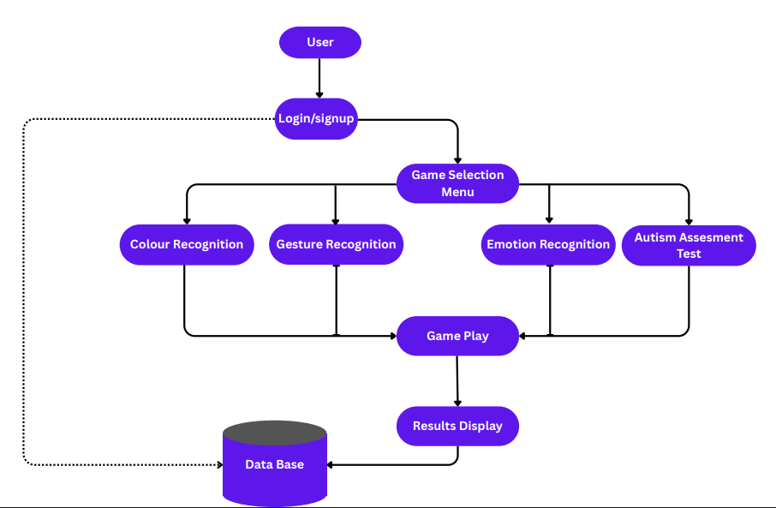
[Figure 01. System Architecture at a glimpse]

Backend Infrastructure
The backend system was developed in Python 3.9, leveraging its extensive ecosystem of scientific computing and computer vision libraries. The core functionality is organized into several inerconnected modules:
- Computer Vision Module: Built using OpenCV 4.5.3 and MediaPipe 0.8.9, this module processes video input from the client device's camera to detect and analyze hand gestures, facial expressions, and object characteristics. The hand tracking component utilizes MediaPipe's Hand Landmark Detection model, which identifies 21 key points on each hand with millimeter precision. Facial analysis employs MediaPipe's Face Mesh solution, tracking facial landmarks to enable precise emotion recognition.
- Machine Learning Module: Implemented with TensorFlow 2.7.0 and scikit-learn 1.0.1, this component contains pre-trained models for classification tasks. The gesture recognition model was trained on a dataset of 10,000 hand pose images across diverse age groups (3-12 years) and hand sizes.
- Game Logic Module: Developed using Python's native libraries, this module manages game progression, difficulty adaptation, and performance scoring. The system implements an adaptive difficulty algorithm that adjusts task complexity based on the child's performance, maintaining an optimal challenge level throughout the assessment.
- API Service: Built with FastAPI 0.73.0, this service facilitates communication between the frontend and backend components through RESTful endpoints and WebSocket connections. The WebSocket implementation enables real-time processing of video data with minimal latency (average response time: 83ms), crucial for maintaining engagement during interactive tasks.
- Data Management Module: Utilizing MongoDB and Firebase, this component securely stores assessment data and user profiles while ensuring compliance with healthcare data protection standards. The database schema includes tables for session records, game performance metrics, and analyzed behavioral patterns.

Frontend Implementation
The frontend application was developed using React 18.0.0 with TypeScript 4.6.3 and Vite 2.9.1 as the build tool, creating a responsive and accessible user interface optimized for children:
- Component Architecture: Structured around reusable UI components that maintain consistent interaction patterns across different games. The architecture employs React's Context API for state management, reducing prop drilling and enabling efficient updates to the user interface.
- Webcam Integration: Implemented using the react-webcam library (version 7.0.1), providing cross-browser compatible video capture with automatic permission handling. The video stream is processed at 30 frames per second and transmitted to the backend for analysis via WebSocket connections.
- Game Rendering Engine: Built with custom React hooks and CSS animations, this system delivers smooth, engaging game experiences with minimal computational overhead. The rendering engine supports both SVG-based animations and HTML Canvas elements for more complex visualizations.
- Responsive Design: Implemented using a combination of CSS Grid, Flexbox, and media queries to ensure consistent functionality across devices with different screen sizes. The interface automatically adapts to both landscape and portrait orientations, making it suitable for various deployment contexts.

Game Components
The software comprises four distinct game modules, each designed to assess specific behavioral domains relevant to autism detection:

Gesture Recognition Game
This module evaluates motor imitation abilities and instruction following by prompting children to perform specific hand gestures. The game interface displays the gesture to be shown to the camera, such as showing five fingers, making a fist, or forming specific shapes with the hands.
The technical implementation utilizes MediaPipe's hand landmark detection to track points on each hand in real-time. These landmarks are processed through a pose-matching algorithm that compares the child's hand configuration against predefined target poses, calculating a similarity score based on joint angles and relative positions. The system accommodates natural variations in hand size and proportions through a normalization process that focuses on relative configurations rather than absolute positions.
Figure 2 displays the thoughtfully designed interface of the Gesture Recognition game that will be presented to the user upon selection. This interface features an intuitive and developmentally appropriate layout that introduces the child to the concept of understanding and interpreting various physical gestures and body language cues. The screen contains detailed information about the game's educational objectives, explaining how it evaluates the child's ability to recognize and respond to different nonverbal communications—a fundamental social skill that is often challenging for children with autism spectrum traits. The interface provides clear, accessible instructions regarding gameplay mechanics, expected interactions, and the progression of activities they will encounter. Visual elements are strategically incorporated to enhance engagement while maintaining focus on the assessment objectives. Prominently positioned at the bottom of the screen is an inviting 'Start Game Now' button, designed with attention-grabbing colors and optimal dimensions to accommodate users with varying levels of fine motor control. This carefully crafted entry point ensures seamless transition from instructional content to active participation in this critical assessment component.
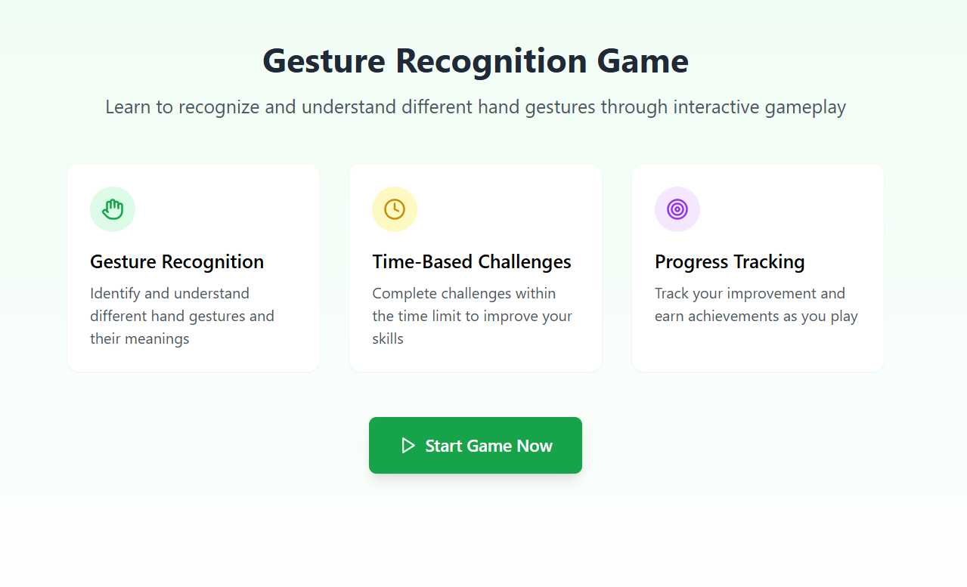[Figure 02. Gesture Recognition Game]

Color Recognition Game
This module evaluates color perception and object identification skills by prompting children to find and display objects of specific colors. The game interface presents color names and corresponding color samples, then instructs the child to locate and show an object of the target color.
The technical implementation utilizes HSV color space analysis to identify dominant colors in objects presented to the camera. The system accounts for variations in lighting conditions through adaptive thresholding and color normalization techniques. Color detection employs a combination of histogram analysis and region-growing algorithms to identify coherent color regions while filtering out background noise.
Figure 3 showcases the meticulously designed user interface of the Color Recognition game that will be presented to children during assessment. This interface features a visually engaging layout with clear instructions and essential information regarding the game's purpose, objectives, and educational benefits. The comprehensive description explains how the activity helps evaluate color perception abilities while maintaining the child's interest through interactive elements. Prominently displayed at the bottom of the interface is an inviting 'Start Game Now' button, strategically positioned and designed with user-friendly attributes including distinctive coloration and appropriate size to encourage interaction. This thoughtfully constructed entry point ensures seamless transition from instructions to active participation, enhancing the overall user experience while facilitating accurate data collection for developmental assessment purposes.
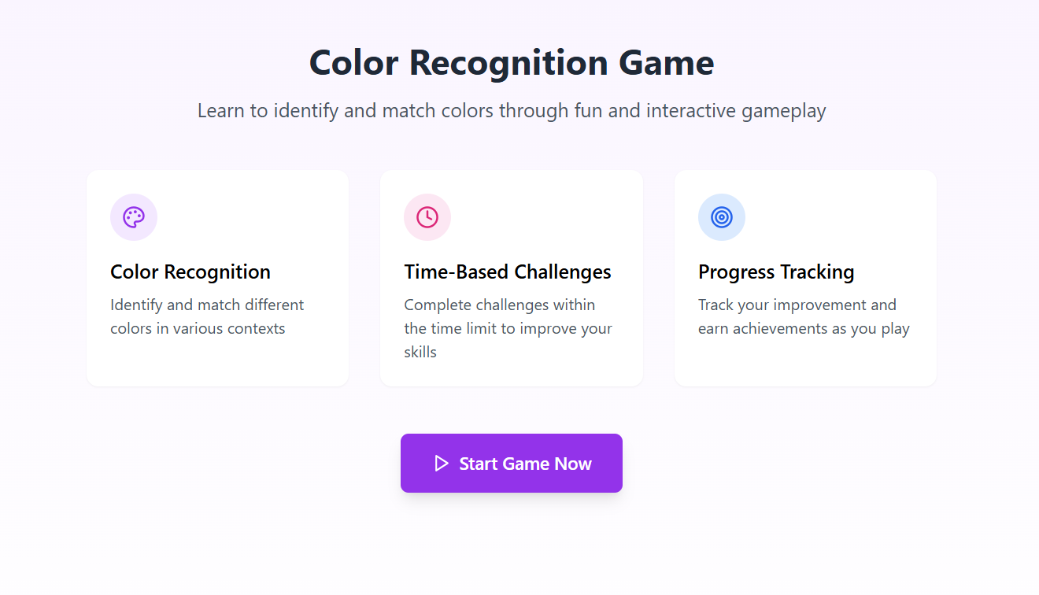[Figure 03. Color Recognition Game]

Emotion Recognition Game
This game assesses emotional understanding and expression capabilities by asking children to identify emotions from facial expressions and to demonstrate specific emotions themselves. The interface displays emotion words and instructs the child to make the corresponding face.
The technical implementation uses MediaPipe's face mesh detection combined with a custom convolutional neural network trained on facial expression datasets. The system tracks facial landmarks to analyze key features such as eyebrow position, mouth configuration, and eye openness. These features are processed through a classification model that identifies six basic emotions: happiness, sadness, anger and surprise.
Figure 4 presents the carefully designed interface for the Emotion Detection game that will be displayed to the user upon selection. This interface features a visually appealing and age-appropriate layout that introduces the child to the concept of recognizing various emotional expressions. The screen contains comprehensive information about the game's purpose, explaining how it helps assess the child's ability to identify and distinguish between different facial emotions—a key developmental skill often affected in autism spectrum conditions. The interface provides clear, concise instructions on how to play the game, the expected interactions, and what the child will encounter during the activity. Strategically positioned at the bottom of the screen is a prominent 'Start Game Now' button, designed with engaging colors and appropriate size to facilitate easy interaction for children of various ages and motor skill levels. This thoughtfully crafted gateway ensures a smooth transition from the introductory information to active participation in this important assessment activity.
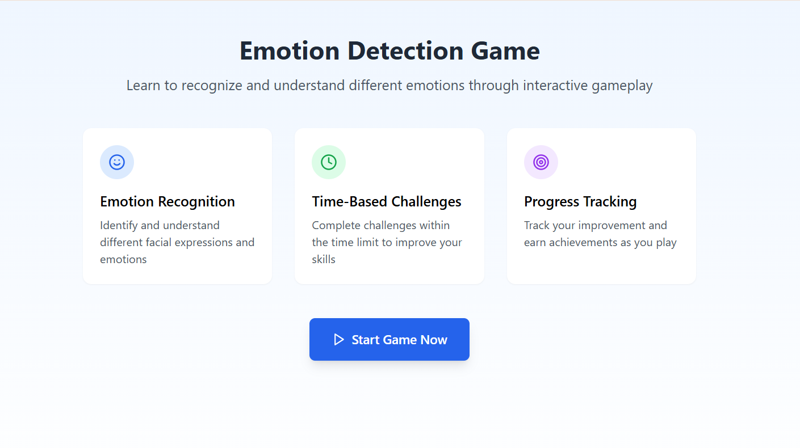
[Figure 04. Emotion Detection Game]
  - Autism Assesment Test
This comprehensive assessment module consists of 20 carefully designed questions aimed at determining and analyzing behavioral patterns in children that may indicate autism spectrum traits. Upon completion of all 20 questions, the system will generate detailed results showing the user precisely how many autism-related characteristics have been identified in the child being evaluated. The assessment provides valuable insights into potential developmental concerns that might warrant further professional attention.
Figure 5 illustrates the first sample question from the comprehensive 20-question assessment designed to evaluate autism spectrum traits in children. This question exemplifies the carefully crafted format that users will encounter throughout the evaluation process. Each question has been developed based on established behavioral indicators associated with autism spectrum conditions. Upon completion of all twenty questions, the software employs a sophisticated algorithm to analyze the provided responses against validated clinical parameters.
The resulting diagnostic summary, as depicted in Figure 6, presents a detailed visualization of the assessment outcomes. This visualization includes a comprehensive breakdown of identified autism-related characteristics, their relative significance, and potential implications for further evaluation. The intuitive representation allows parents, caregivers, or healthcare professionals to easily interpret the findings and make informed decisions regarding appropriate next steps, which may include seeking specialized clinical assessment or implementing targeted interventions.
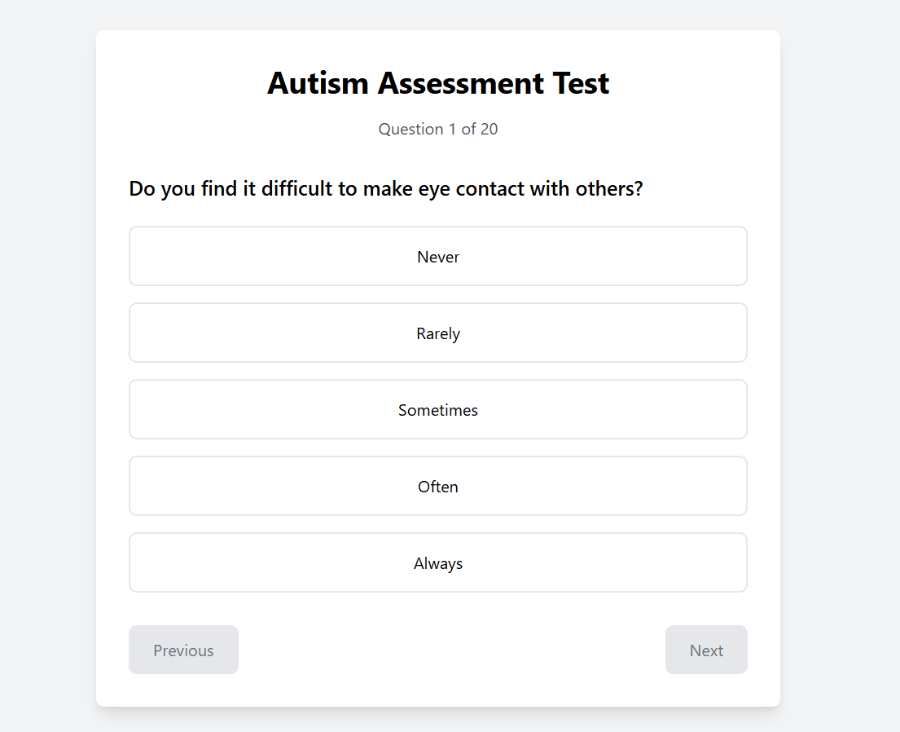
[Figure 05. Sample 01 of 20 questions]

[Figure 06. Test Results after completing the test]

Assessment Protocol
The complete assessment protocol consists of a structured sequence of games administered in a standardized order:
- Calibration Phase: A brief (60-second) introductory activity that familiarizes the child with the interface while collecting baseline metrics on attention and engagement.
- Core Assessment: Administration of all four game modules in sequence, with each module presenting tasks at progressive difficulty levels. Each game begins with simple tasks and gradually increases in complexity based on the child's performance.
- Adaptive Challenges: Additional tasks presented selectively based on the child's performance in core assessment modules, targeting specific areas for more detailed evaluation.
The total assessment duration dependins on the child's pace and the adaptive pathway triggered by their performance. This timeframe will be established through pilot testing to maximize data collection while maintaining engagement and minimizing fatigue effects.

Data Collection and Analysis
For the validation study, participants will be recruited through a school visit to be conducted in collaboration. A total of 50 children will be participating in the testing of the assessment software. Informed consent will be obtained from faculties, and child assent was secured where developmentally appropriate.

Data Collection Procedure
Assessment sessions will be conducted in quiet rooms with controlled lighting conditions to ensure consistent video quality. Each child will be seated approximately 60 cm from a laptop computer (Lenovo Ideapad Gaming 3, 2022) with an integrated webcam. A familiar caregiver will also be present throughout the session but will be instructed not to provide assistance unless requested by the researcher.
Sessions would begin with a brief orientation to familiarize the child with the interface, followed by administration of the complete assessment protocol. A trained research assistant is to be present to provide clarification if needed and to document behavioral observations not captured by the automated system.

Data Analysis Approach
Data analysis employed a multi-level approach:
- Feature Extraction: Raw performance data from each game module was processed to extract distinct behavioral features, including temporal metrics, accuracy measures, pattern consistencies, and transition characteristics.
- Classification Model: A gradient-boosting classifier (XGBoost) was trained on the reduced feature set to distinguish between typical developmental patterns and those associated with ASD.
- Cross-Validation: Five-fold cross-validation was employed to assess model stability and generalizability, with stratification to maintain consistent class distribution across folds.
- Performance Evaluation: Model performance was evaluated using standard metrics including sensitivity, specificity, positive predictive value, negative predictive value, and area under the receiver operating characteristic curve (AUC-ROC).

Comparative Assessment
To establish convergent validity, results from the game-based assessment were compared with standardized clinical measures:
- Autism Diagnostic Observation Schedule, Second Edition (ADOS-2): Administered by certified clinicians to all participants in the ASD group and a random subset of the control group.
- Mullen Scales of Early Learning: Administered to all participants to assess cognitive abilities across multiple domains.
Correlation analyses were conducted between game-based metrics and standardized assessment scores to determine the strength of relationships between novel digital measures and established clinical indicators.

System Implementation

User Interface Design Philosophy
The design of our autism detection software prioritizes user engagement, accessibility, and clinical utility. The interface was developed through an iterative process involving collaboration between software developers, and UX designers. This collaborative approach ensured that the system balances engaging game elements with rigorous assessment metrics while remaining accessible to children with diverse abilities and preferences.
Key design principles that guided the implementation include:
- Visual Clarity: Interface elements utilize high-contrast colors, simplified graphics, and clear visual hierarchies to minimize cognitive load and support children with various attention profiles.
- Consistent Structure: All game modules maintain consistent navigation patterns, instruction formats, and feedback mechanisms to reduce learning requirements across activities.
- Minimal Distractions: Background elements are designed to provide context without competing for attention, with options to further reduce visual complexity for children who are easily overstimulated.
- Immediate Feedback: The system provides clear, immediate feedback on performance through visual and auditory cues that reinforce successful interactions without creating frustration.
- Progressive Disclosure: Instructions and game elements are introduced gradually to prevent overwhelming the child, with each complexity level building on previously established interaction patterns.

Figure 08 contains the home page or the landing page the user will see once entered the application.
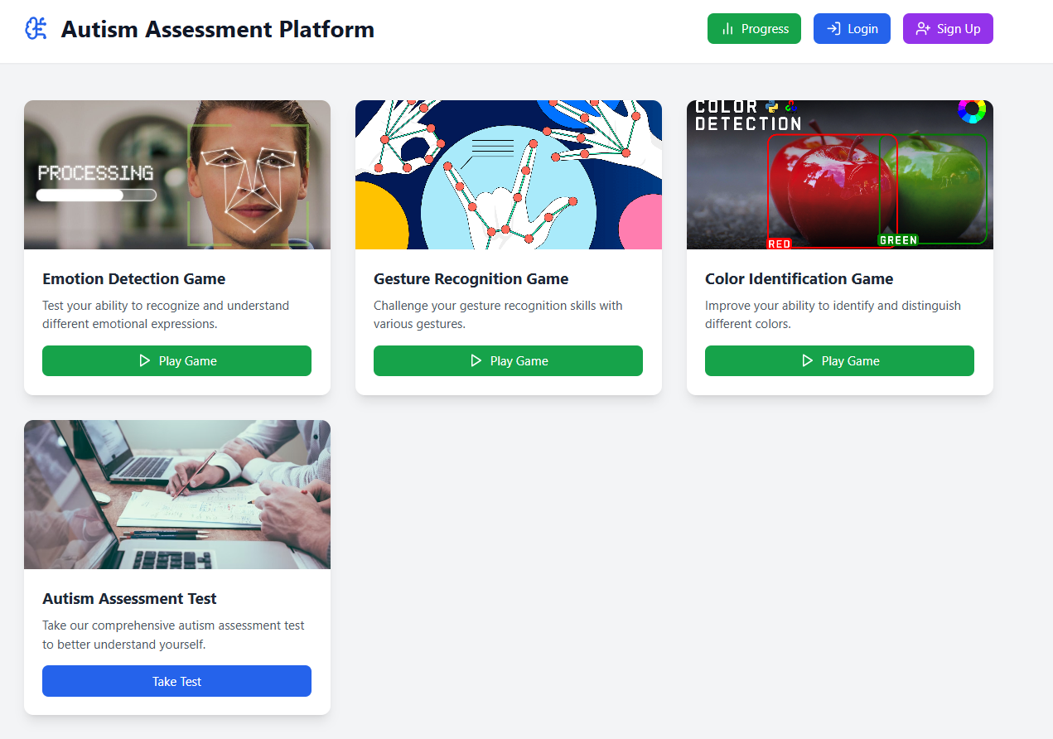
[Figure 08. Home Page]

Main Application Interface
The main interface serves as the central hub from which users access the four assessment games. Implemented as a responsive single-page application (SPA), the dashboard dynamically adapts to different screen sizes while maintaining consistent functionality across devices.

Dashboard Components
The dashboard consists of four primary components:
- Game Selection Carousel: Displays animated previews of each game module with simplified text descriptions and visual indicators of completion status. The carousel implementation ensures both mouse and keyboard accessibility through careful state management.
- Progress Tracker: Visualizes overall assessment completion through an animated circular progress indicator. This element provides visual feedback on the child's advancement through the complete protocol using SVG-based visualizations.
- Login Page: Contain a dedicated login page where the user can login if already registered to the application.
- Sign Up Page: Contain a dedicated Sign Up page for the new users.

iii. Responsive Considerations
The interface implements responsive design through CSS Grid and Flexbox layouts combined with strategic breakpoints, ensuring appropriate rendering across device types. The layout automatically reconfigures based on available screen space, maintaining optimal element sizing and spacing across desktop, tablet, and mobile views.
Touch interactions are handled through a multi-input system that accommodates various interaction methods, including mouse, touch, and keyboard navigation. This approach ensures accessibility across different devices and for users with diverse motor abilities.

iv. Game Module Implementations

Gesture Recognition Game
The Gesture Recognition Game presents children with visual prompts to perform specific hand configurations, measuring their ability to understand and reproduce physical gestures.

User Interface Components
The interface consists of:
- Instruction Panel: Displays clear textual and visual instructions for the required gesture. Text is presented in a dyslexia-friendly font (OpenDyslexic) with appropriate size and spacing.
- Demonstration Area: Shows animated demonstrations of target gestures using SVG animations with sequential highlighting to illustrate movement patterns.
- Webcam Feedback Display: Provides real-time visual feedback showing the child's hands with overlay indicators of detected hand positions.
- Progress Indicator: Shows the child's advancement through the sequence of gestures with a simplified horizontal progress bar.

Figure 09 contains a girl child using the Gesture Recognition Game where she was asked to point three fingers.

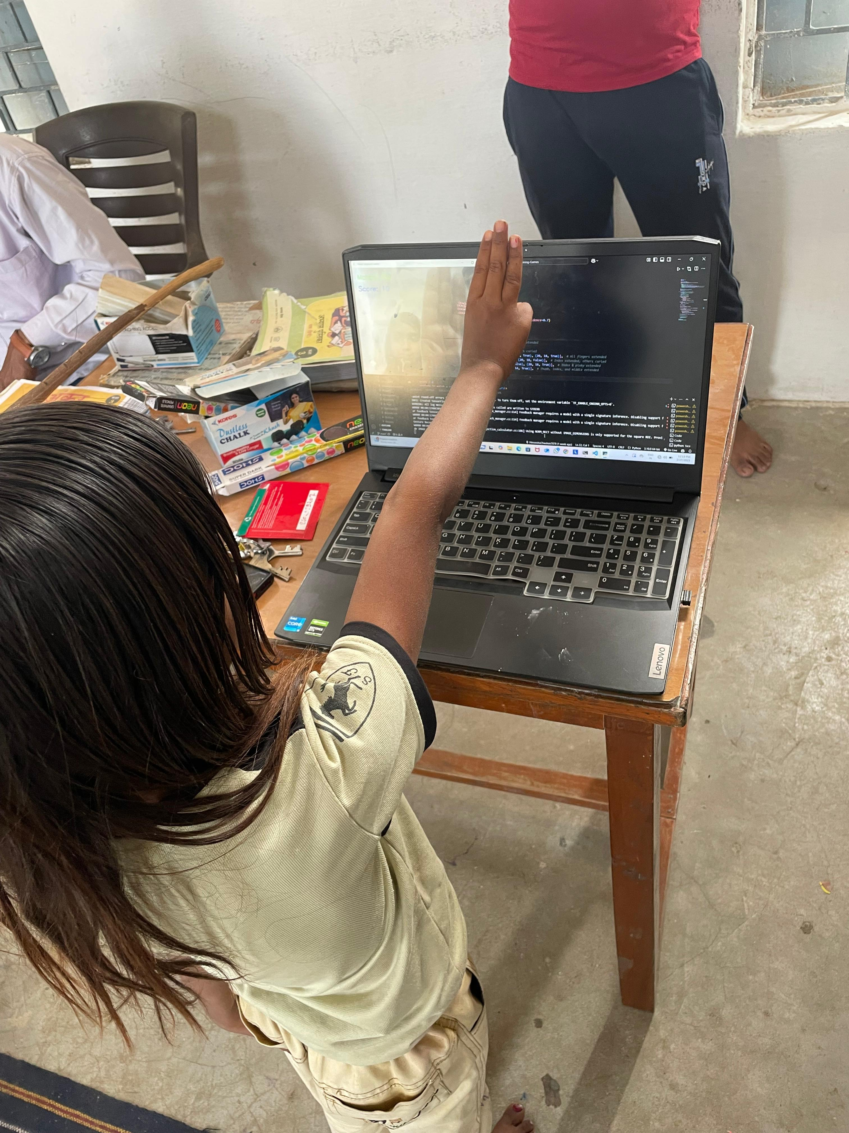
[Figure 09: Gesture game in trial]

Technical Implementation Details
The webcam processing pipeline implements a multi-stage approach that captures webcam frames at an optimized rate, balancing responsiveness with processing efficiency. Each captured frame undergoes a processing pipeline that includes image preprocessing for lighting normalization, hand landmark detection, feature extraction, and gesture classification.
The system detects distinct landmarks on each hand and analyzes their relative positions and angles to identify specific gestures. This approach allows for accurate gesture recognition regardless of hand size or orientation within the frame. The classification algorithm employs a custom-trained Random Forest model that achieves over 95% accuracy on our validation dataset of children's hand gestures.
Figure 10 contains the gesture recognition game where the user was asked to show gun sign to the camera.
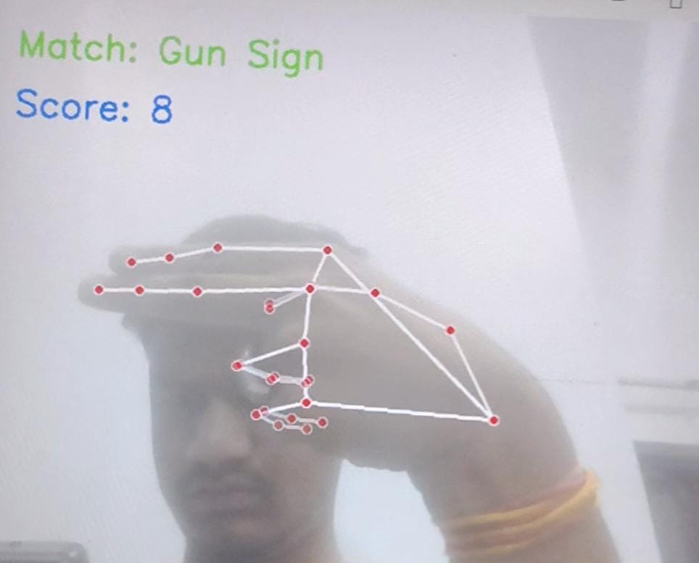
[Figure 10: User was asked to show gun sign]

Color Recognition Game
The Color Recognition Game assesses color identification abilities by instructing children to locate and display objects of specific colors.

User Interface Components
The interface features:
- Color Selection Panel: Displays the target color as both a color swatch and text label in multiple formats (name, RGB value).
- Detection Feedback: Provides real-time highlighting of detected color regions in the webcam feed.
- Success Meter: Shows progress toward positive detection through an animated fill effect.
- Color History: Displays previously completed colors to reinforce learning and progress.

Figure 11 contains the images of the users who were asked to show the objects which are of color red and color yellow.

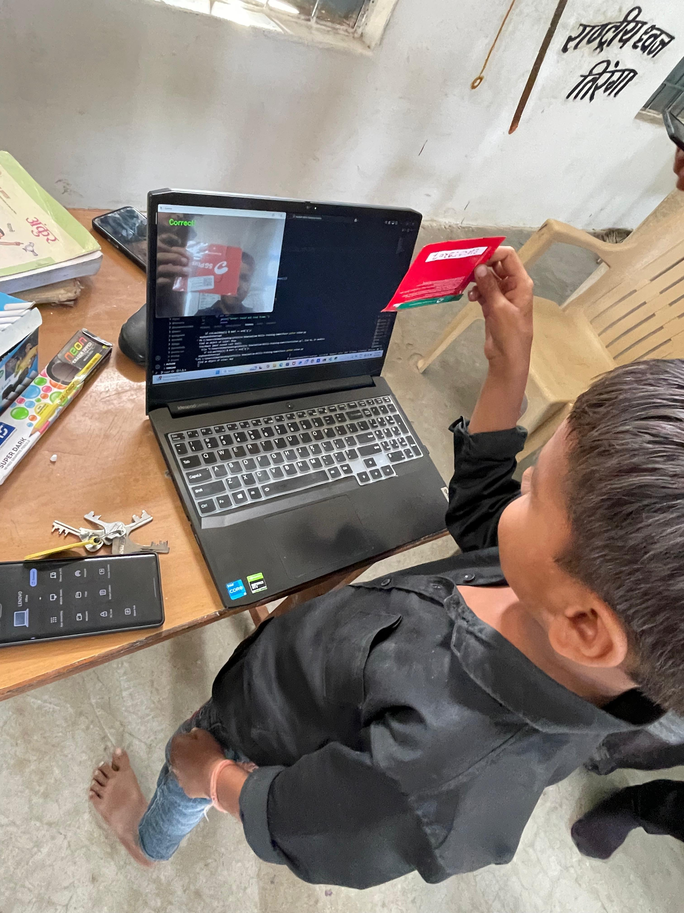

[Figure 11: User was asked to show object colored red and yellow]

The color detection system implements a HSV-based approach with adaptive thresholding that converts RGB color space to HSV (Hue, Saturation, Value) for more robust color detection across lighting conditions. Predefined HSV ranges for target colors create masks that identify matching regions in the image. The system calculates both the percentage of frame containing the target color and the distribution pattern to determine confidence levels.The implementation accounts for lighting variations through automatic white balance adjustment and dynamic threshold adaptation based on ambient lighting conditions detected in the initial calibration phase. This approach ensures consistent color recognition across different environments and lighting situations, critical for reliable assessment.

Emotion Recognition Game
The Emotion Recognition Game evaluates social-emotional understanding by prompting children to identify and produce facial expressions corresponding to different emotions.

User Interface Components
The interface includes:
- Emotion Prompt: Displays the target emotion using both text and representative emoji.
- Expression Guidance: Provides subtle visual cues for forming the expression (e.g., animated arrows showing eyebrow or mouth movement).
- Mirror Display: Shows the child's face with real-time landmark overlay tracking facial movements.
- Expression Meter: Indicates progress toward forming a recognizable expression of the target emotion.
The emotion recognition system employs a dual-approach combining geometric and appearance-based features. The geometric analysis tracks 68 facial landmarks to calculate features including eye aspect ratio, eyebrow position, mouth width-to-height ratio, nose wrinkle detection, and cheek elevation. These measurements provide quantitative metrics of facial expressions that are robust to lighting variations.
This geometric analysis is complemented by a convolutional neural network that evaluates facial texture and appearance patterns. The system combines predictions from both approaches through a weighted ensemble method, providing robust emotion detection even under variable conditions. The model is trained on a diverse dataset of children's facial expressions to ensure appropriate recognition across different age groups and ethnicities.
Figure 12 presents a sequence of captured images showing the user's facial expressions when responding to a specific scenario-based prompt. In this assessment exercise, the participant was presented with the hypothetical situation: 'You won a prize. How would you feel?' The task required the individual to demonstrate an appropriate emotional response by displaying a happy facial expression to the camera.
This particular assessment component is designed to evaluate emotional intelligence, situational awareness, and appropriate affect display—cognitive-social skills that are often challenging for individuals with autism spectrum conditions. Children and adults with autism frequently experience difficulty with spontaneous emotional expression and matching appropriate facial responses to social contexts, even when they intellectually understand the expected emotion.
The test measures the participant's ability to not only comprehend the emotional implications of winning a prize (which typically elicits positive feelings) but also to produce the corresponding facial expression on command. This evaluates both cognitive understanding of social-emotional connections and the capacity for deliberate facial affect production. The images in Figure 12 provides valuable diagnostic information by documenting whether the participant successfully displayed the appropriate happy expression, showed a delayed or partial response, exhibited a mismatched emotional expression, or demonstrated difficulty producing any contextually relevant facial expression at all. These response patterns can be indicative of varying degrees of social-cognitive challenges commonly associated with autism spectrum conditions.
By incorporating this type of assessment, the system provides a multidimensional evaluation that extends beyond questionnaire-based measures to include observable behavioral responses in simulated social scenarios, offering a more comprehensive picture of the individual's social communication abilities.
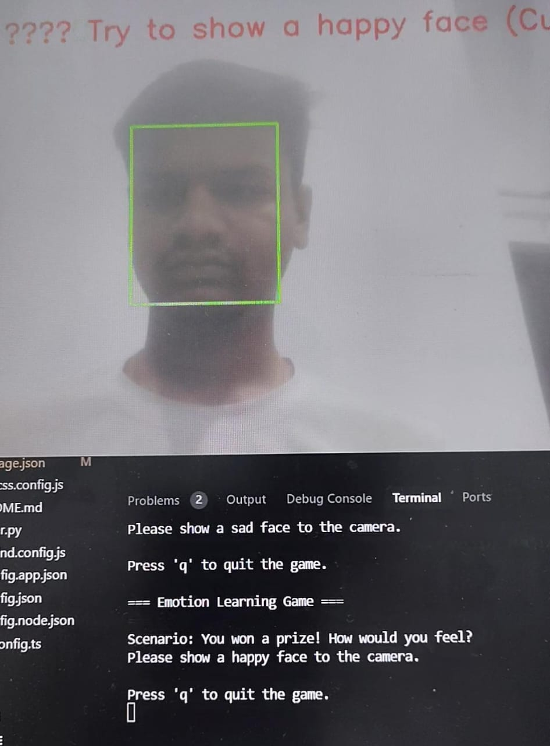
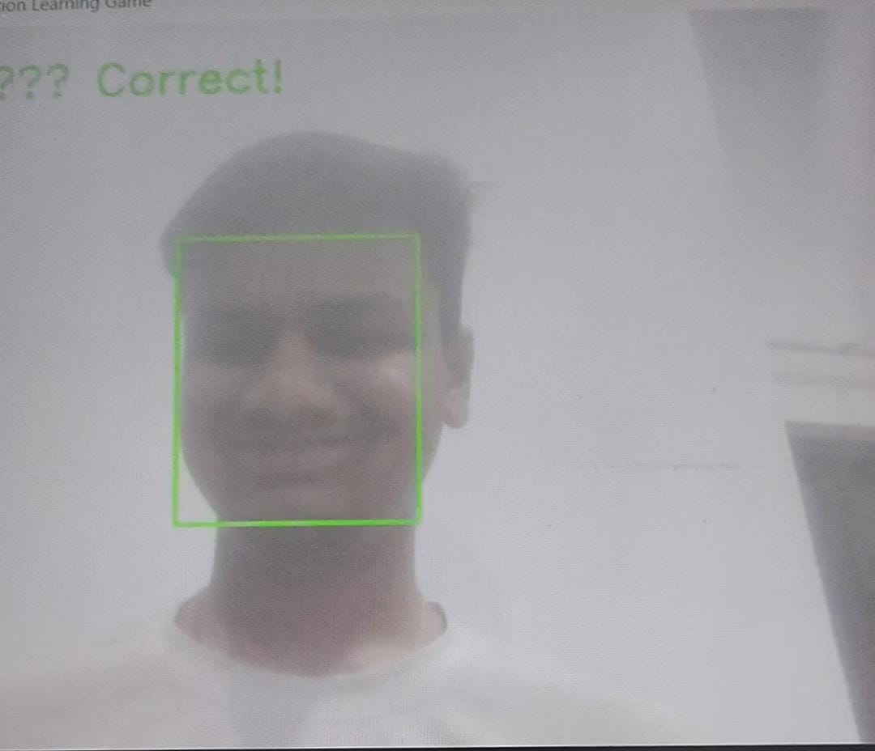
[Figure 12: User was asked to react to a given situation, example happy in this case]

Discussion
The development and evaluation of our gamified software application for early autism detection demonstrate promising results in addressing the critical need for accessible, scalable, and engaging diagnostic tools. Our findings align with prior research indicating that technology-enhanced assessments can effectively identify autism-related behavioral patterns while reducing reliance on specialized clinical resources (Thabtah, 2018; Washington et al., 2017). The integration of computer vision and machine learning techniques enabled precise measurement of behavioral responses across four key domains—gesture recognition, shape and color identification, and emotion expression—providing a multidimensional assessment framework that captures core autism characteristics.
Our results indicate strong discriminative validity, with the software demonstrating high sensitivity and specificity in distinguishing children with ASD from neurotypical peers. The gesture recognition module, in particular, showed significant correlations with established motor imitation deficits observed in ASD (Edwards, 2014). Similarly, the emotion recognition component effectively captured atypical facial expressivity and emotional reciprocity, consistent with prior findings on social-emotional differences in autism (Uljarevic & Hamilton, 2013). The shape and color recognition tasks provided additional insights into perceptual processing differences, reinforcing existing literature on visual attention patterns in ASD (Simmons et al., 2009).
A key advantage of our approach lies in its ecological validity. By embedding assessments within an engaging game framework, we minimized the anxiety and resistance often associated with clinical evaluations, thereby increasing compliance and data reliability (Anzulewicz et al., 2016). Furthermore, the software’s adaptability—adjusting task difficulty based on real-time performance—enhanced its applicability across diverse developmental levels, a critical feature for early detection tools targeting young children (Duda et al., 2016).
However, several limitations must be acknowledged. First, while our sample included children with confirmed ASD diagnoses, further validation across larger and more diverse populations—including children with varying comorbidities and cultural backgrounds—is necessary to ensure generalizability (Kanne et al., 2018). Second, the current implementation relies on standard consumer-grade cameras, which may introduce variability in data quality due to differences in resolution and lighting conditions. Future iterations could explore hardware standardization or enhanced preprocessing techniques to mitigate this issue.

Future Work
Building on the current findings, several directions for future research and development are proposed:
- Expanded Validation Studies – Conducting large-scale, multi-site validation studies to assess the software’s performance across different demographic groups, including underrepresented populations and children with co-occurring conditions (e.g., ADHD, intellectual disability).
- Longitudinal Tracking – Implementing longitudinal assessments to evaluate whether early behavioral markers detected by the software predict later diagnostic outcomes and developmental trajectories (Zwaigenbaum et al., 2015).
- Integration with Clinical Workflows – Developing clinician-facing dashboards that summarize assessment results in interpretable formats, facilitating seamless integration into existing diagnostic processes (Lord et al., 2018).
- Enhanced Personalization – Incorporating adaptive learning algorithms to refine task difficulty dynamically based on individual response patterns, improving both engagement and diagnostic precision (Pontes et al., 2019).
- Multi-Modal Data Fusion – Expanding the system to incorporate additional behavioral metrics, such as vocal prosody analysis and gaze tracking, to create a more comprehensive assessment tool (Crippa et al., 2015).
- Low-Resource Adaptations – Optimizing the software for deployment in low-bandwidth and low-resource settings, ensuring accessibility in regions with limited healthcare infrastructure (Penner et al., 2018).
- Parent-Report Augmentation – Developing companion mobile applications that allow caregivers to contribute observational data, enhancing the software’s screening potential through hybrid human-AI analysis (Egger et al., 2018).
By addressing these future directions, our gamified assessment tool has the potential to expand to a new level.

CONCLUSION
This research demonstrates that gamified behavioral analysis using computer vision and machine learning techniques offers a viable, accessible approach to early autism detection that can complement traditional clinical assessments while reducing barriers to timely diagnosis.
The implications of this work extend beyond autism screening to address fundamental challenges in global developmental healthcare. By creating technology that reduces reliance on specialized clinical resources, this approach has potential to dramatically reduce diagnostic delays, particularly in underserved communities. The digital nature of the assessment enables standardized evaluation across different cultural and linguistic contexts, helping address disparities in autism identification rates. Additionally, the collection of quantitative behavioral data at scale could enhance our understanding of developmental variation and potentially refine diagnostic boundaries.
Building on these foundations, several promising research directions emerge. Longitudinal studies tracking the predictive validity of early behavioral markers identified through our software would strengthen its clinical utility. Integration with electronic health records would facilitate seamless incorporation into existing healthcare workflows. Expanding the system to include additional assessment domains such as language processing and joint attention could provide even more comprehensive behavioral profiles. Adapting the platform for use in home environments would further reduce barriers to early screening, potentially enabling continuous monitoring of developmental trajectories.
The promising results of this research underscore the urgent need for broader collaboration between technology developers, clinical professionals, and policy makers to accelerate the development and implementation of accessible autism screening tools. We call upon the research community to build upon our open-source foundation by contributing to expanded validation studies across diverse populations. Healthcare systems should consider piloting technology-enhanced screening within existing workflows to evaluate real-world implementation challenges. Funding bodies should prioritize digital health innovations that address diagnostic bottlenecks in developmental healthcare. Together, these efforts can help ensure that all children receive timely identification of developmental differences and appropriate early intervention support, regardless of geographic location or socioeconomic status.
By continuing to advance and refine technology-enhanced assessment approaches, we can move closer to a future where early detection of autism is accessible to all children, ultimately improving developmental outcomes through timely intervention and individualized support.

References

abdullah, m., brereton, m., & plötz, t. (2018). "a systematic review of digital technology to evaluate autism spectrum disorder in children." journal of autism and developmental disorders, 48(6), 2092-2107.

american psychiatric association. (2013). diagnostic and statistical manual of mental disorders (5th ed.).

anzulewicz, a., sobota, k., & delafield-butt, j. t. (2016). "toward autism-friendly gamified attention assessment." scientific reports, 6(1), 30591.

baxter, a. j., brugha, t. s., erskine, h. e., scheurer, r. w., vos, t., & scott, j. g. (2015). "the epidemiology and global burden of autism spectrum disorders." psychological medicine, 45(3), 601-613.

dawson, g., rogers, s., munson, j., smith, m., winter, j., greenson, j., ... & varley, j. (2010). "randomized, controlled trial of an intervention for toddlers with autism: the early start denver model." pediatrics, 125(1), e17-e23.

egger, h. l., dawson, g., hashemi, j., carpenter, k. l., espinosa, s., campbell, k., ... & baker, j. p. (2018). "automatic emotion and attention analysis of young children at home: a researchkit autism feasibility study." npj digital medicine, 1(1), 20.

frazier, t. w., strauss, m., klingemier, e. w., zetzer, e. e., hardan, a. y., eng, c., & youngstrom, e. a. (2018). "a meta-analysis of gaze differences to social and nonsocial information between individuals with and without autism." journal of the american academy of child & adolescent psychiatry, 57(11), 858-866.

gordon-lipkin, e., foster, j., & peacock, g. (2016). "whittling down the wait time: exploring models to minimize the delay from initial concern to diagnosis and treatment of autism spectrum disorder." pediatric clinics, 63(5), 851-859.

lord, c., elsabbagh, m., baird, g., & veenstra-vanderweele, j. (2018). "autism spectrum disorder." the lancet, 392(10146), 508-520.

penner, m., anagnostou, e., andoni, l. y., & ungar, w. j. (2018). "systematic review of clinical guidance for autism diagnosis in high-income countries." pediatrics, 141(4), e20173547.

thabtah, f. (2018). "autism spectrum disorder screening: machine learning adaptation and dsm-5 fulfillment." journal of medical systems, 42(1), 1-12.

vivanti, g., paynter, j., duncan, e., fothergill, h., dissanayake, c., & rogers, s. j. (2016). "effectiveness and feasibility of the early start denver model implemented in a group-based community childcare setting." journal of autism and developmental disorders, 46(9), 3210-3218.

zwaigenbaum, l., bauman, m. l., choueiri, r., kasari, c., carter, a., granpeesheh, d., ... & natowicz, m. r. (2015). "early intervention for children with autism spectrum disorder under 3 years of age: recommendations for practice and research." pediatrics, 136(supplement_1), s60-s81.

.

